|  |  |
| --- | --- |
| **Ex.no:** | **CALL BY VALUE AND CALL BY REFERENCE** |
| **Date:** |

**AIM:**

Towrite a C program to swap two integer values using call by value & call by reference.

**ALGORITHM:**

**STEP 1**: Start the program.

**STEP 2:** Declare the variable x, y, temp in int data type

**STEP 3:** Get the values for x and y from the user

**STEP 4:** Swapping using call by value

**STEP 5:** temp = x

**STEP 6:** x = y

**STEP 7:** y = temp

**STEP 8:** Display the output after swapping

**STEP 9:** End the program.

**PROGRAM:**

#include <stdio.h>

void swapByValue(int x, int y)

{

int temp;

temp = x;

x = y;

y = temp;

printf("Inside swapByValue: x = %d, y = %d\n", x, y); } void swapByReference(int *x, int *y)

{

int temp;

temp = *x;

*x = *y;

*y = temp;

}

int main()

{

int a, b;

printf("Enter two integers (a and b): ");

scanf("%d %d", &a, &b);

printf("Original values: a = %d, b = %d\n", a, b); swapByValue(a, b);

printf("After swapByValue: a = %d, b = %d\n", a, b); swapByReference(&a, &b);

printf("After swapByReference: a = %d, b = %d\n", a, b); return 0;

}

**OUTPUT:**

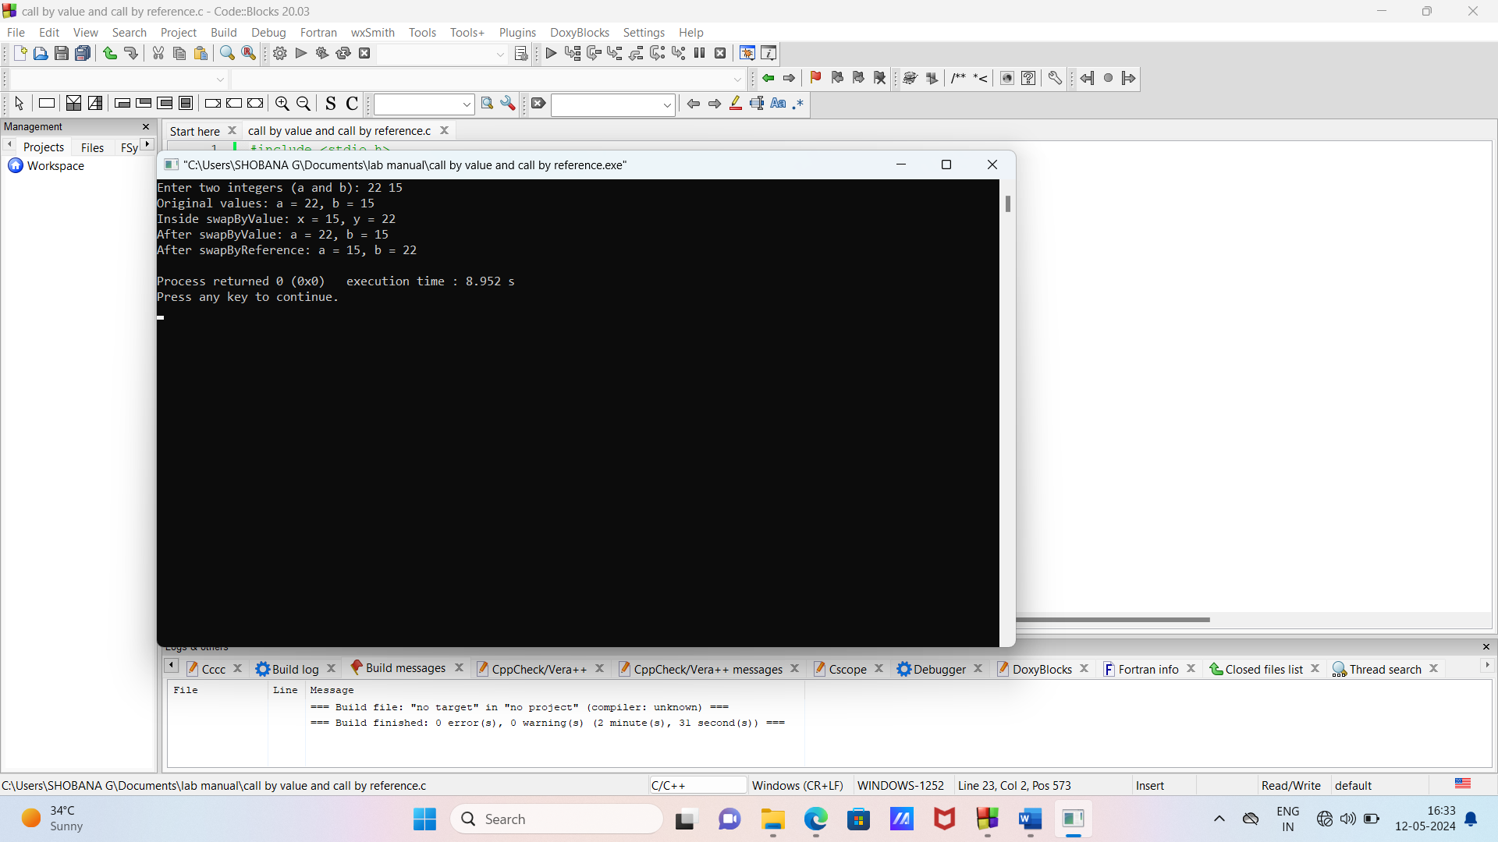

**RESULT:**